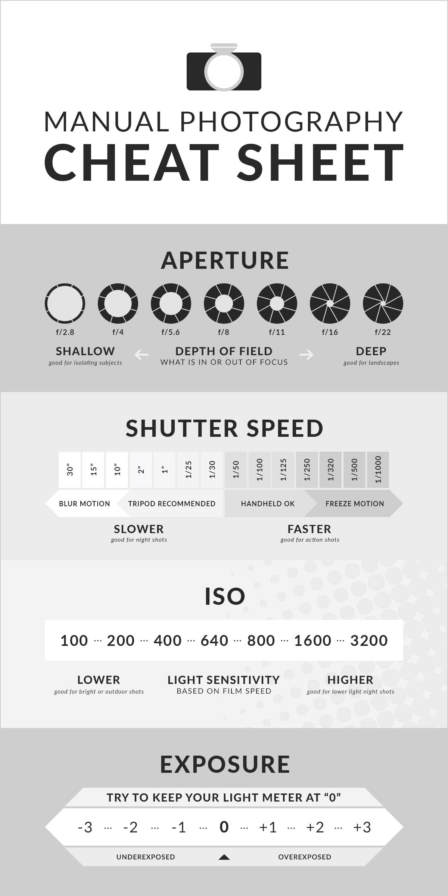
ON THE CAMERA: Focus: very front ring of lens Zoom: turn the wide ring of the lens
Looks like: F#
Press button and thumb wheel

Looks like: # (possibly in a fraction)
- If you see “, you are working in whole seconds, not fractions of a second!! Ex. 30” is 30 seconds
Use thumb wheel only to change

May see it as ISO#
or if there is a display on the top of the camera- it only appears when you hit the
Change: Most of the camera, you have to go into menu, some you can hold the ISO button and turn the thumb wheel

**Great way to check your exposure level PRIOR to taking the photo!**
There is a level in the viewfinder that shows you if your exposure level is balanced. Aim the camera at your subject and partially hold the shutter. The level will appear. Adjust while looking through the viewfinder! Some have this on the back screen as well.

