Creating a Photo Collage in Photoshop

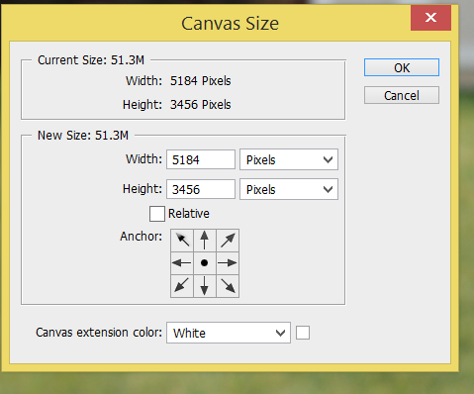
Before you begin here you should have:
- Taken a LOT of photos close up of your subject matter (read more on the class website)
- Edited photos as needed prior to starting to move the photos for the collage

Step 1: Create a new Canvas
The Canvas is a blank page that you can add your photos onto, but first you need to know the size of the photo.
a. Click the Image tab. Select Canvas size. You should be able to see the width and height of your current canvas (the size of the photo) in Pixels.
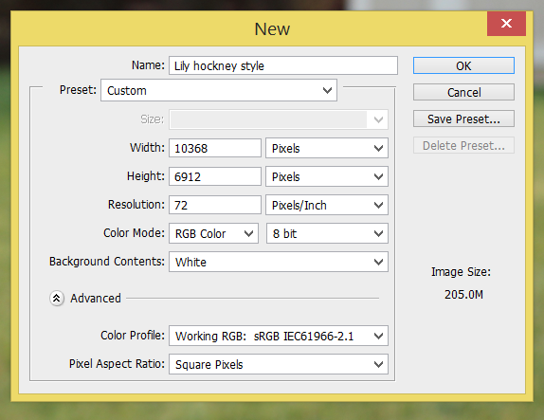
*If you don’t, click the drop down arrow next to the numbers and select Pixels.
b. Get your calculator out! You want to find what 2x the height and width would be for your new canvas.
Example: my photos are 5184x3456 pixels so my new canvas will need to be 10368x6192. There isn’t really a specific number here. It is really just allowing to create a Canvas that is bigger than the original photos. You can edit this later!
c. Click the File tab. Click New. It will bring up a window like you see here.
You need to:
- Give your file a name (anything you want)
- Set the width at 2x your photo size
- Set your height at 2x your photo size

Step 2: Choosing your photos
Look through your photos that you have and figure out about 10 to start with that you think you will use. You will probably add more (and remove a few) as you go, but it’s a good starting point.
a. Organize!
Make a new file folder- create a file folder within the current one to copy the photos you plan to use. It will help you when you need to find them later!
Rename the photos you are planning to start with before opening them in photoshop. Even if you name them something “left eye close up” or “chin2,” it will help you when you are flipping around through your files in Photoshop! After all, the file name is all you see on the top tab bar when you have multiple files open…this will help you find the file you want without having to click between them constantly!
b. Open each file in Photoshop you are starting with. You will see the file names in tabs at the top.
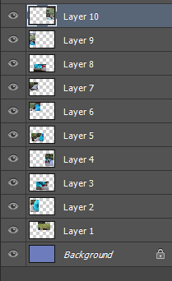
c. To move the photos, use the Move tool
Select All by hitting Ctrl+A
It selects the entire photo. Click and drag the photo to your new canvas on the tab above and let go of the mouse button once you are onto the canvas.
d. Continue this for each photo. Each photo becomes a new layer on the Canvas.

About your Layers... Important!
*Notice how each photo is a layer on the layers window.
*The layer you are currently working with will be bracketed in the layers window.
*Each photo and its placement on the canvas is shown in a little picture on the layer
*If you can’t tell what layer a photo is, you can right click it and it will tell you the layer #
*You can click the little “eye” on a layer and it will hide it (helps to see where it is on the canvas!)
*You can put one photo “over” another by moving it in the layers window. Click and hold the layer above or below another and it will change where it is positioned (front to back) in the collage.

Step 3: Create the Look of your Collage
- More than likely you will need to shrink the size of the photos some. Adjust the size of the photos to your liking. If the adjustment brackets are not around the photo, you can hit Ctrl+T (or check the “Show Transform Controls” window in the top tool bar).
*Don’t forget to double click (or click the check mark on the bar above) to set the size. Otherwise Photoshop won’t let you do anything else!
- Move photos around from front to back or back to front by moving them in the layers window.
- Add more photos to fill in the collage (and maybe remove some you don’t want).
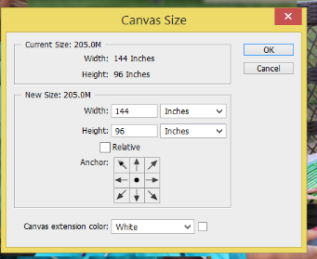
*to remove a photo, drag its layer down to the trash can. *You might want to hide it instead (by clicking the eye next to its layer) if your not totally sure you don’t want it.
- Change the size of the Canvas- do you want the background color to be larger, wider, taller? You can adjust the canvas. Here’s how:
-click the Image tab. Choose Canvas size. The window will appear.
-if you want the entire canvas larger, adjust the pixel size up in increments until you get the size you’d like
-if you’d like to add canvas to one side, add the pixel size for the width or height and click the arrow in the window to add it to side you’d wish.

Step 4: Create Drop Shadows
Creating drop shadows on the individual photos gives the collage the illusion of being layered like a real photo collage would. Here’s how:
a. Click the “Fx” button on the bottom of the layers window (or go to Layer on the top tool bar, chose Layer Style).
b. Select Drop Shadow (at the bottom of the options window that pops up)
The drop shadow window will appear. You can create a cast shadow off of each individual photo.
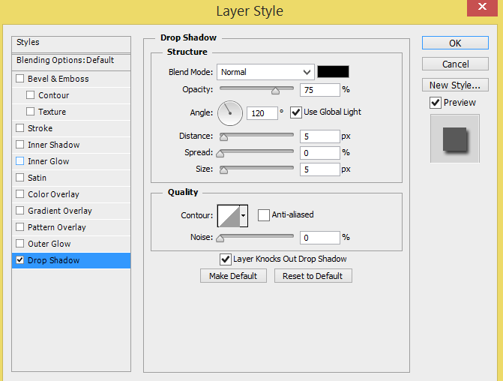
Here’s some options:
Blend Mode: choose Normal
Color: (probably defaulted to black) click the color window and change to what you’d like…I’d suggest gray or black
Opacity: gives the degree of opacity to transparency
Angle: turn the little dial to change the direction of the shadow
Distance, Spread and Size: adjust to get the shadow width and look you want
*To use the same settings for multiple layers, go to Layers, Layer style, copy layer style. Then click on any other layers you wan to copy it to- go to layers, layers style, paste layers style.

Step 5:Background Color
You can leave the background white or you can add color to the background canvas to compliment the collage. a. Select the background layer in the layers window.
b. Select the paint bucket click the color window and the “color picker” window will pop up.
c. click anywhere on your background and the color will change.

Last Step:Saving the Collage
You will want to save this assignment in 3 ways…and here is why- what if, after you have saved this file, you realized that you need to fix something? Nooooooo! If you have saved it as a Jpeg, all of the layers have flattened to one layer and you can’t fix it or move any photos. 2nd reason- the photo will more than likely be too large for weebly.
Save in this order: If you save as a Jpeg first, it will automatically flatten the layers and you can’t edit!!!
1. Do NOT flatten! Save As a PSD (photoshop file). This will allow you to go back and edit. All layers will still be there!
2. Flatten the layers. Save As a Jpeg to the maximum file size.
3. Save As a Jpeg and name something different than the original file (I usually call it the original and add weebly. Instead of choosing the maximum file size, try “high”. If the size is still too big (over10M) then try medium.
*If the file is still too big, you will need to cancel and change the Canvas size before saving-I can help with this!

