Creating Your WORD art Photo!
1. Decide on a word that you would like to make (4 letter minimum).
2. Open each file in Photoshop and make any necessary editing (levels, crop, color corrections, etc…)
*Keep in mind that you want the letters to stay the same basic height and width, so don’t crop a photo into a square.
3. Create a new Canvas:
Use the formula below to create a new canvas that you will drag your letter onto
- Look at the image size of one of your photos (if you took the photos with the same type of camera, they should all be the same size. If you took some with your phone, and some with a camera, ask for help). Go to Image, Image Size, and change the option to pixels)
WIDTH OF CANVAS:

_____________ X _______________= _______________
# of photos width in pixels total A

(_____________ X 200) + 300 = _______________
# of photos-1 total B

Add Total A with Total B to get : ____________________ for the TOTAL WIDTH OF CANVAS

HEIGHT OF CANVAS:

____________ + 300= _______________
Height of photo TOTAL HEIGHT OF CANVAS
in pixels

4. Move your photos to the new document-
Just like in other assignments, use Crtl+A to select a photo. Use the Mover tool to move the photo to the new canvas. Each letter will become a new layer on the canvas. **It would make it easier if you move them in order!
TIPS!
*To adjust the individual photos: remember you have to be on THAT photo’s layer in order for it to move. Quick solution- right click the letter you want to move and its layer number will come up. Click it and then move it!
*If the photo keeps snapping in a place you don’t want… Photoshop has a handy tool called snapping. It naturally lines photos up in a row, which can be helpful. It can also be irritating if it’s not going where you want! To override snapping, hold the Crtl key while moving the photo.

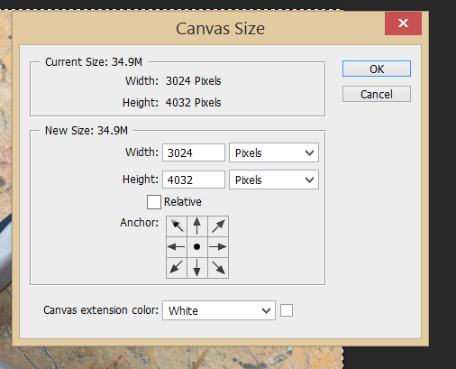
If there is not enough space for all of your letters- Go up to Image-Canvas size- and a window will come up. Switch to pixels if it shows inches. Adjust the amount from there. *If you’d like to add space to a specific direction, for instance you have all the photos spaced evenly but you just want a little more to the right of your last letter, there is a set of arrows at the bottom that you can direct for your sizing change!
Use a grid to line up your letters- Go to View (top tool bar)- Show- Grid. It will allow you to line up your photos with precision.
Excess Canvas Space?- Crop!

6. ADD Color to your Background Canvas
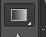
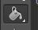
Make sure you are on your Canvas layer.
Go the left tool bar and choose the paint bucket . *If you don’t see it, you may see the gradient tool instead . Press and hold on the gradient tool, and the paint bucket option will appear.
Go down to the black/white squares on the bottom and click on the black (top) square. It will bring up a gradient scale of color choices for you. If you want black (that is my preference for this) then leave it all alone. If you want another color, choose it now. Click ok. Bring your mouse onto the canvas and click. It will change to your color choice. You can do this at any point during the process, so you have the ability to change your mind later!
TIP! If you want to choose a color from a photo for the Canvas- choose the ink dropper tool first and click over the color in the photo. Then go to the paint bucket and click on the canvas.

7. Saving your file-
1. Save as a PSD (Photoshop file) while working and at the end (for safe keeping)
2. Flatten the Image (go to Layer, then Flatten image)
3. Make the Image size smaller: Go to Image, Image Size, make sure the “constrain proportions” is checked, and adjust the width smaller (about 7,000 pixels)
4. Save as a Jpeg at Maximum (unless it shows over 10MB. If so, save as High)
*When you close out, do not save the changes to your PSD file after you have flattened the image. You will not be able to make changes to it once it is saved as a flattened file.

