PHOTO 1
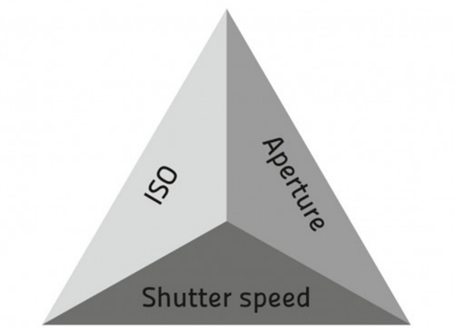
DSLR Camera Terms and Info
Light+ISO+F-stop+Shutter Speed=
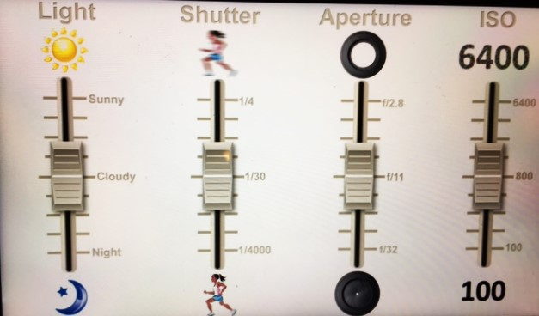
Total Result
If you change one, the rest need to
adjust!

DSLR- Digital Single Lens Reflex camera
Exposure- the amount of light reaching the image sensor. This is controlled through a combination of shutter speed, ISO setting, and aperture (F-stop)

ISO- the sensitivity of the sensor. The higher the #, the more sensitive it is to light (used for darker settings). *The higher the number, the lower the quality the photo can become. Best to set as low as possible without sacrificing your need for shutter speed and aperture.
F-Stop/Aperture- This setting controls the focal length used in a photo. The aperture is like the pupil of the camera’s eye. The more open it is, the more light is let in. The number is technically a fraction, so the higher number represents a smaller aperture or F-stop #.
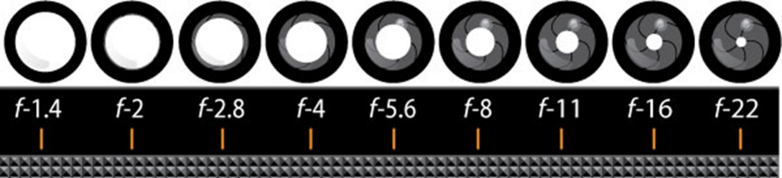
Lower F-Stop- lets in more light/ also good for shallow depth of field images (close-ups)
Higher Depth of Field- lets in less light/ good for distance photos (landscapes)

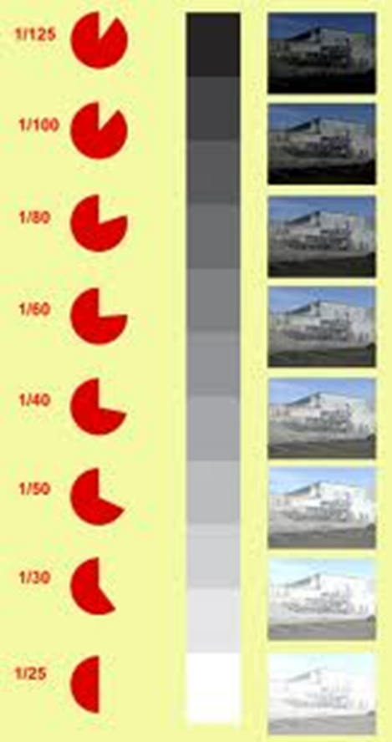
Shutter Speed- the shutter is like the “eye lid.” The shutter closes when you press the button to take a picture. How quickly that shutter closes changes how much light is let in and how quickly the images are read by the camera. The speed is the length of time that the sensor is exposed during the photo taking process. The number is a fraction, so the quicker shutter speeds are the higher bottom number.
Fast shutter speed- less blur, bright lighting
Slower shutter speed- want blurring, night or low light shot

Exposure Compensation- +/- adjusts the brightness from your current setting

Different “Modes”
M- on the Camera is fully manual mode
TV or S- on the Camera is an option for only manually controlling the Shutter. The camera will choose the F-stop and ISO.
AV- on the camera settings you choose the focal length (F-stop/aperture) while the camera will auto adjust the ISO and shutter speed.
*Manual is the optimum use of the camera, but it can come in handy to stick with one the other options in certain settings.

