EXPOSURE
Exposure is the amount of light reaching the image sensor in the back of the camera that records the image being taken.
Underexposed photos do not have enough light and will look dark. Slightly underexposed photos may be saved through brightening on the computer, but it can lead to grainy photos or loss of detail in the photo.
Overexposed photos will look overbright, or they may have overbright (white) areas. Overexposed areas in a photo will not be retained in the image, so it cannot be fixed. Some cameras will flash in these areas in playback mode.
Properly exposing a photo is what we are looking for when working with the camera. To get a properly exposed photo, you have to adjust your ISO, Aperture (F-stop), and Shutter speed to balance one another. Think of every photo situation like these controls below:
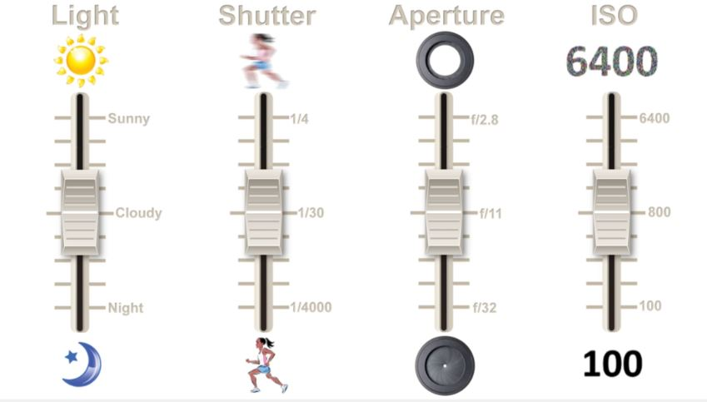
If you change one dial, the others have to adjust to compensate from more or less light entering the camera. _____________________________________________________________________________
How do you know if you have the correct settings?
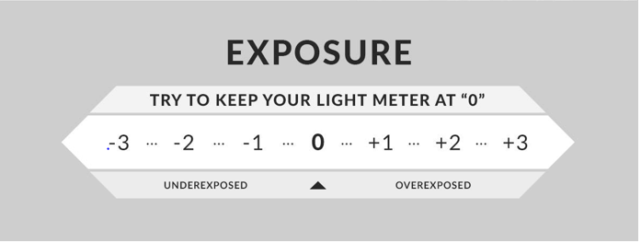
The camera has a meter inside the view finder (and some show it on the display as well). If the camera’s settings are in balance, you will see the camera meter in the center. If you are underexposed, the camera will show to the negative side of the meter. If you are over, the camera will meter towards the plus sign. *Of course, the camera is not always correct in every situation. Sometimes, especially if you are trying to capture dramatic lighting or objects that are dark in color, the camera may meter incorrectly. Trust your eye to see the difference! IF you aren’t sure, take several photos above and below the metered mark!

Setting Up Your Camera for Good Exposure
1. Gauge your Lighting- Indoors? Outdoors? Low or high lighting?
2. Set your ISO-
Less light=higher ISO more light=lower ISO
*Remember! Higher ISO’s get grainy when printed or enlarged. Try to as stay low as possible.*

3. Set your priority setting- Aperture or Shutter first?
How do you know which is your priority?
-if you are focused on capturing objects in focus at different distances, then Aperture (Fstop) is your priority
-if you are trying to capture fast movement or slow movement, then shutter is your priority.

Aperture priority-
Low F-stop=close up photos/ mid F#= mid-range distance/ high F-stop #=distant photos
Shutter priority-
Faster shutter speed=freezes motion with no blur
Slower shutter= captures and sees motion/blur
*to capture people without blur, you typically want to be over 1/200
*to avoid seeing your own camera shake, do not go under 1/40 without a tripod

4. Set your last setting to get correct exposure- IMPORTANT!
If you set Aperture above, adjust your shutter to get a centered meter reading
If you set Shutter above, adjust your aperture to get a centered meter reading

-2- - - 1- - - - - - 1 - - - 2+

Underexposed Overexposed
Proper exposure!

