Moving an object to a different photo!
**Read “Selecting an object and Refining 1st!*

1. 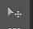Choose the Move tool on the left tool bar. Drag the object (or even whole photo) towards the tab at the top where the other file name is located.
*IF you are moving the entire photo (not just a selected object) hit Ctrl+A and it will automatically select the whole image!*
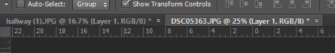
2. Adjust the Object to fit into the Background:
A) Adjust size- Ctrl+T and drag the corner to adjust the size/ space bar+mouse to move the position.
B) Remove parts to fit into the Background- if you want to make the object look like it fits more naturally into the background, you may need to remove some parts. For example, if I moved an animal into a grassy background, I may want to remove parts of its feet to look like it is sitting IN the grass, not above it.
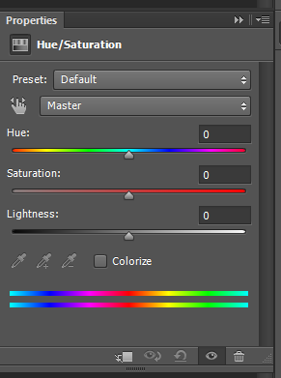
To do this- select the mask on the objects layer. Use the brush tool with the black/white to remove what you want (just like you would with selective color).
C) Making adjustments- Make sure you are on the layer you want to adjust. Go to the top tab and choose Image. Then choose adjustments and choose what adjustment you want to make. It will only adjust that layer and not the whole thing.
*You can also “clip” an adjustment layer to your specific layer by: clicking your adjustment option icon as usual. Then click the clip icon . This will “clip” the adjustment to the layer directly below it only.
7. If you are not finished by the end of the class, save as a PSD, not a jpeg!
**If finished, save as a jpeg!

