What is a DSLR Camera?

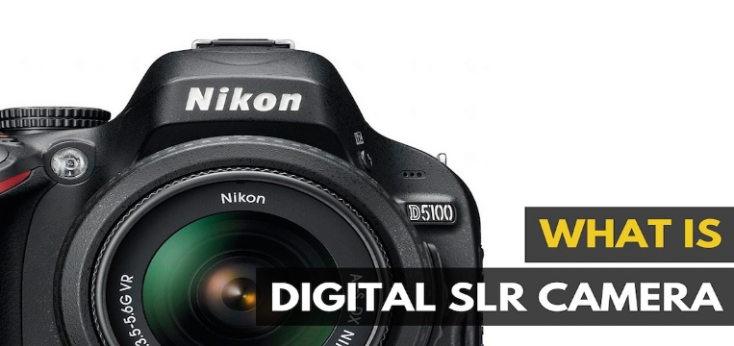
A digital single-lens reflex camera (also called a digital SLR or DSLR) is a digital camera combining the optics and the mechanisms of a single-lens reflex camera with a digital imaging sensor, as opposed to photographic film. The reflex design scheme is the primary difference between a DSLR and other digital cameras. In the reflex design, light travels through the lens, then to a mirror that alternates to send the image to either the viewfinder or the image sensor. The alternative would be to have a viewfinder with its own lens, hence the term "single lens" for this design. By using only one lens, the viewfinder of a DSLR presents an image that will not perceptibly differ from what is captured by the camera's sensor.

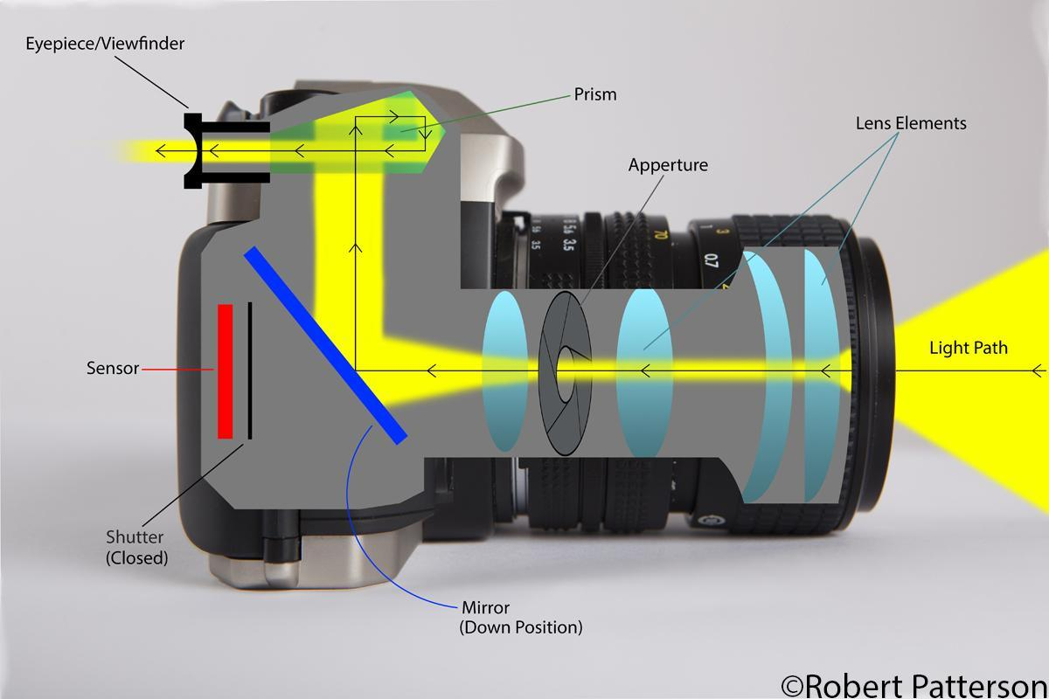
How a DSLR camera works:
https://www.youtube.com/watch?v=XR_AdKkFX94
